
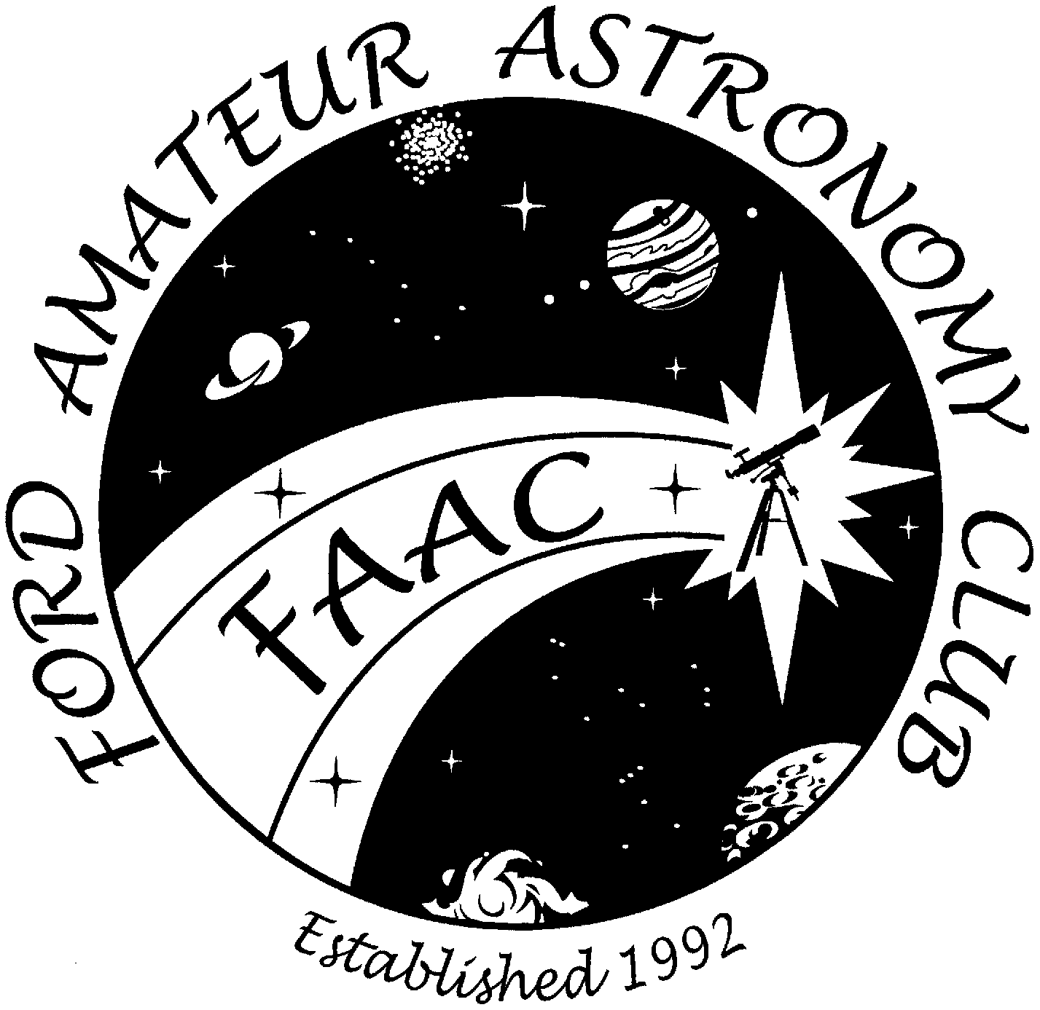
Don’t Miss The 2nd Annual FAAC

Astronomy Swap Meet

Co-hosted by the
Ford Amateur Astronomy Club (FAAC)
& Rider’s Hobby – Livonia

Saturday, February 5, 2005 - 9:00 am to 3:00 pm

Earn Cash By Selling Your Extra:
Telescopes - Eyepieces - Cameras - Binoculars - Mounts
Tripods - Software - Publications & Accessories, etc.
Or, locate that special bargain you might not otherwise find!

Added Feature: ASTRO PRESENTATIONS throughout the day.
FILM ASTRO IMAGING by Clay Kessler at 9:30 am; SKETCHING & OBSERVING by Gary Strumolo at 11:00am; ASTRONOMY 101 by Gordon Hansen at 12:30pm; and VIDEOCAM IMAGING by John Kirchhoff at 2:00pm.

Admission: $5.00 in advance or $6.00 at the door  (children 15 and younger – Free)  Sales Table: $15 in advance, or as available at the  Door, $20 (one admission ticket included).  Advanced Registration ends January 27, 2005.  Doors Open: 8:00am for setup. Complimentary Coffee & Donuts provided by Rider’s Hobby.  Make Checks Payable: to FAAC for advance admission or table registrations. Send payment to Ford Amateur Astronomy Club, P.O. Box 7527, Dearborn, MI 48121-7527 - by Jan. 27, 2005.  Location: Holy Cross Lutheran Church Gymnasium 30650 Six Mile, Livonia, north side of Six Mile, ½ mile east of Merriman. See STAR on map. |  | 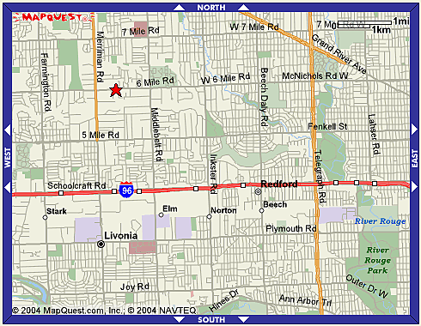
For More Contact Jim via email: w8tu@comcast.net or call (734) 453-1422, or Information: John Kirchhoff via email: riderslivonia@aol.com or call (734) 425-9720

