Scanning MICROFICHE in the Documents Center
University of Michigan Library

1. Bring a USB drive with you.
- Make sure the computer and monitor are on.
- Insert your USB drive into a USB port.
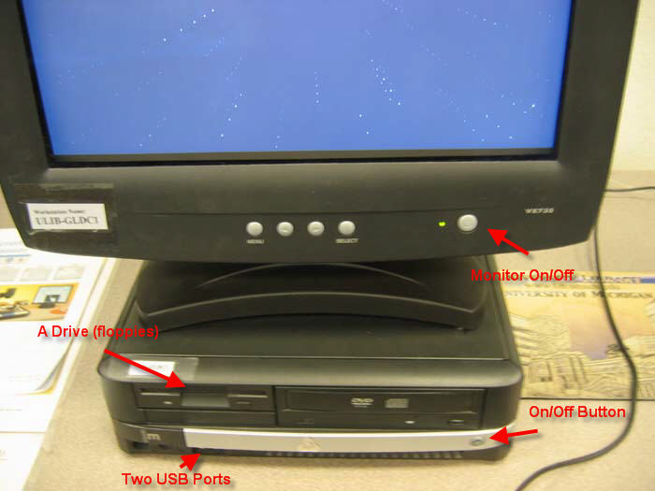

- Turn on the scanner
  - Switch on the back right
  - Lamp light on keyboard
  - Orange tab behind the fiche carrier
- Make sure the lamp arm attached to the left is over the fiche carrier.
- Lay the microfiche on the fiche arm in a face-up position.

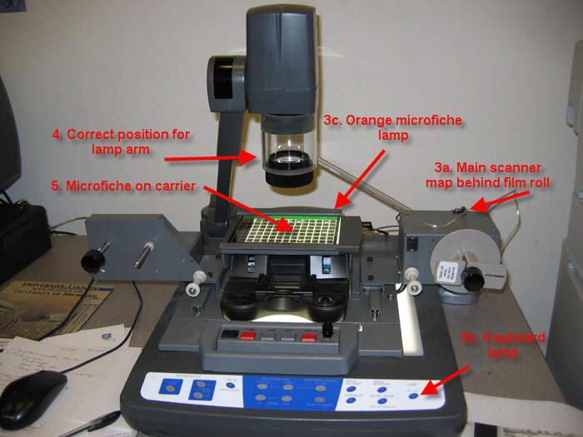

- Viewing your document

  - Click on Viewer Mode (left side of the scanner keyboard) to view your document on the computer screen.
  - Use the Invert Image button to change a black background to a white background and vice versa. However, you may find that a negative fiche with a black background is easier to read in its native form.
  - Zoom in or out but try to fill the screen with the image you want since it will be easier to read later on.
  - PUSH TO FOCUS each time you zoom in and out. Give your document a little while to refocus. Also play around with the brightness controls.
  - When you are ready to scan, press the PC1 button.

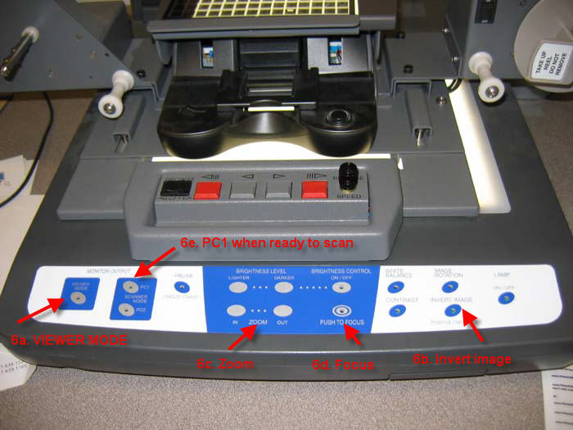

- Logon to the computer with your uniqname and password (or library/library) Choose the ScanWrite software. Press return at the next screen.

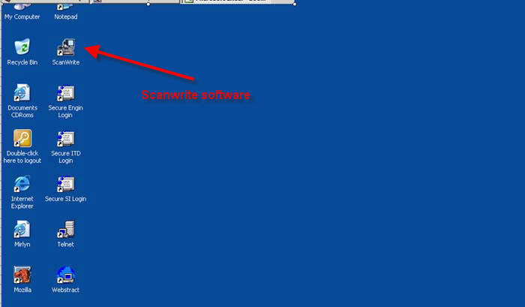
- You should automatically see the “Scan Images” screen. If not, choose “Scan Images” at the top. Choose SNAPSHOT for microfiche and microprint. SELECT.

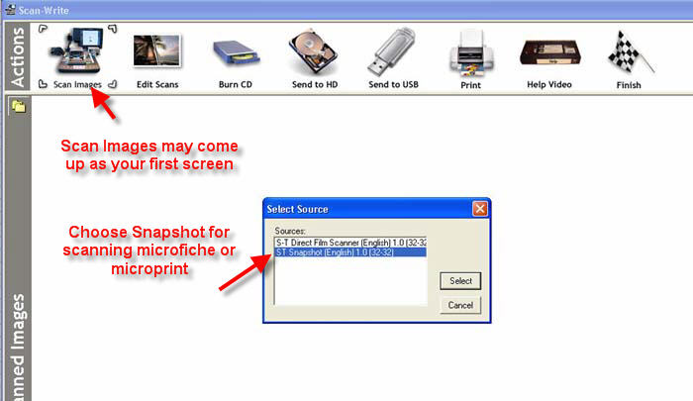

- Preview the snapshot.
  - If you DON’T like the scan, you will need to press “VIEWER MODE” on the scanner, fix it, and then press “PC1” to preview the snapshot again.
  - If you DO like the scan, press PRINT or SEND TO PC (e.g. save).

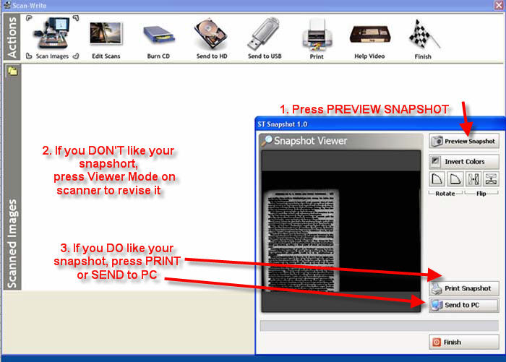

- If you “SEND TO PC,” the page will appear as a small icon in the upper lefthand corner of the screen. You scan another page, press “VIEWER MODE” on the scanner and repeat the process.

- To edit your image, highlight the small icon and press “EDIT SCAN.”
a. You can crop, flip the image, or change the brightness
b. When finished, either PRINT or SEND TO USB.
(Note: the CD writer and Hard Drive are disabled on 9-6-05)
(Picture on next page)

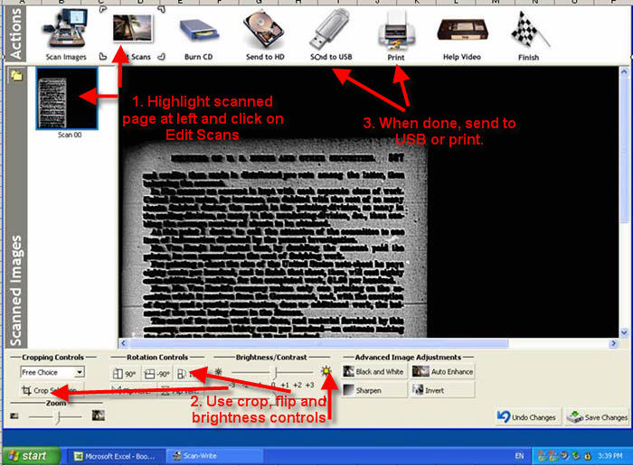

- Final downloading instructions:

  - Choose format
JPEG is the most common image format.
TIFF and PNG are also possible.
PDF – one file – is best for a series of pages.
PDF – multiple files – puts individual pages in its own file.
  - The program will automatically name your file, e.g. Scanwrite00,
Scanwrite 01, etc.
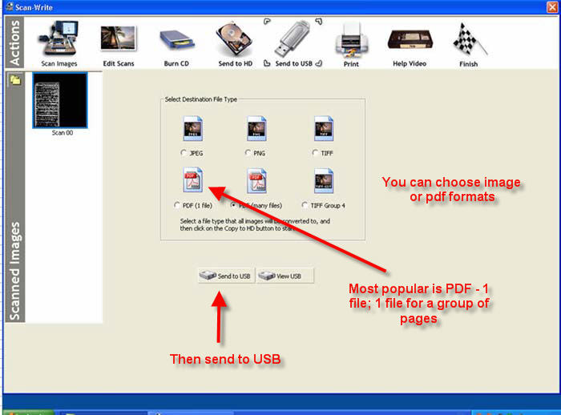

14.Verify your work by opening up MY COMPUTER and your USB file. Click on the
folder you just created. This should open up any images or pdf files without having to find the program on the computer.

For further assistance, see the Documents Center or Serials/Microforms Staff.

GY 9-6-05

