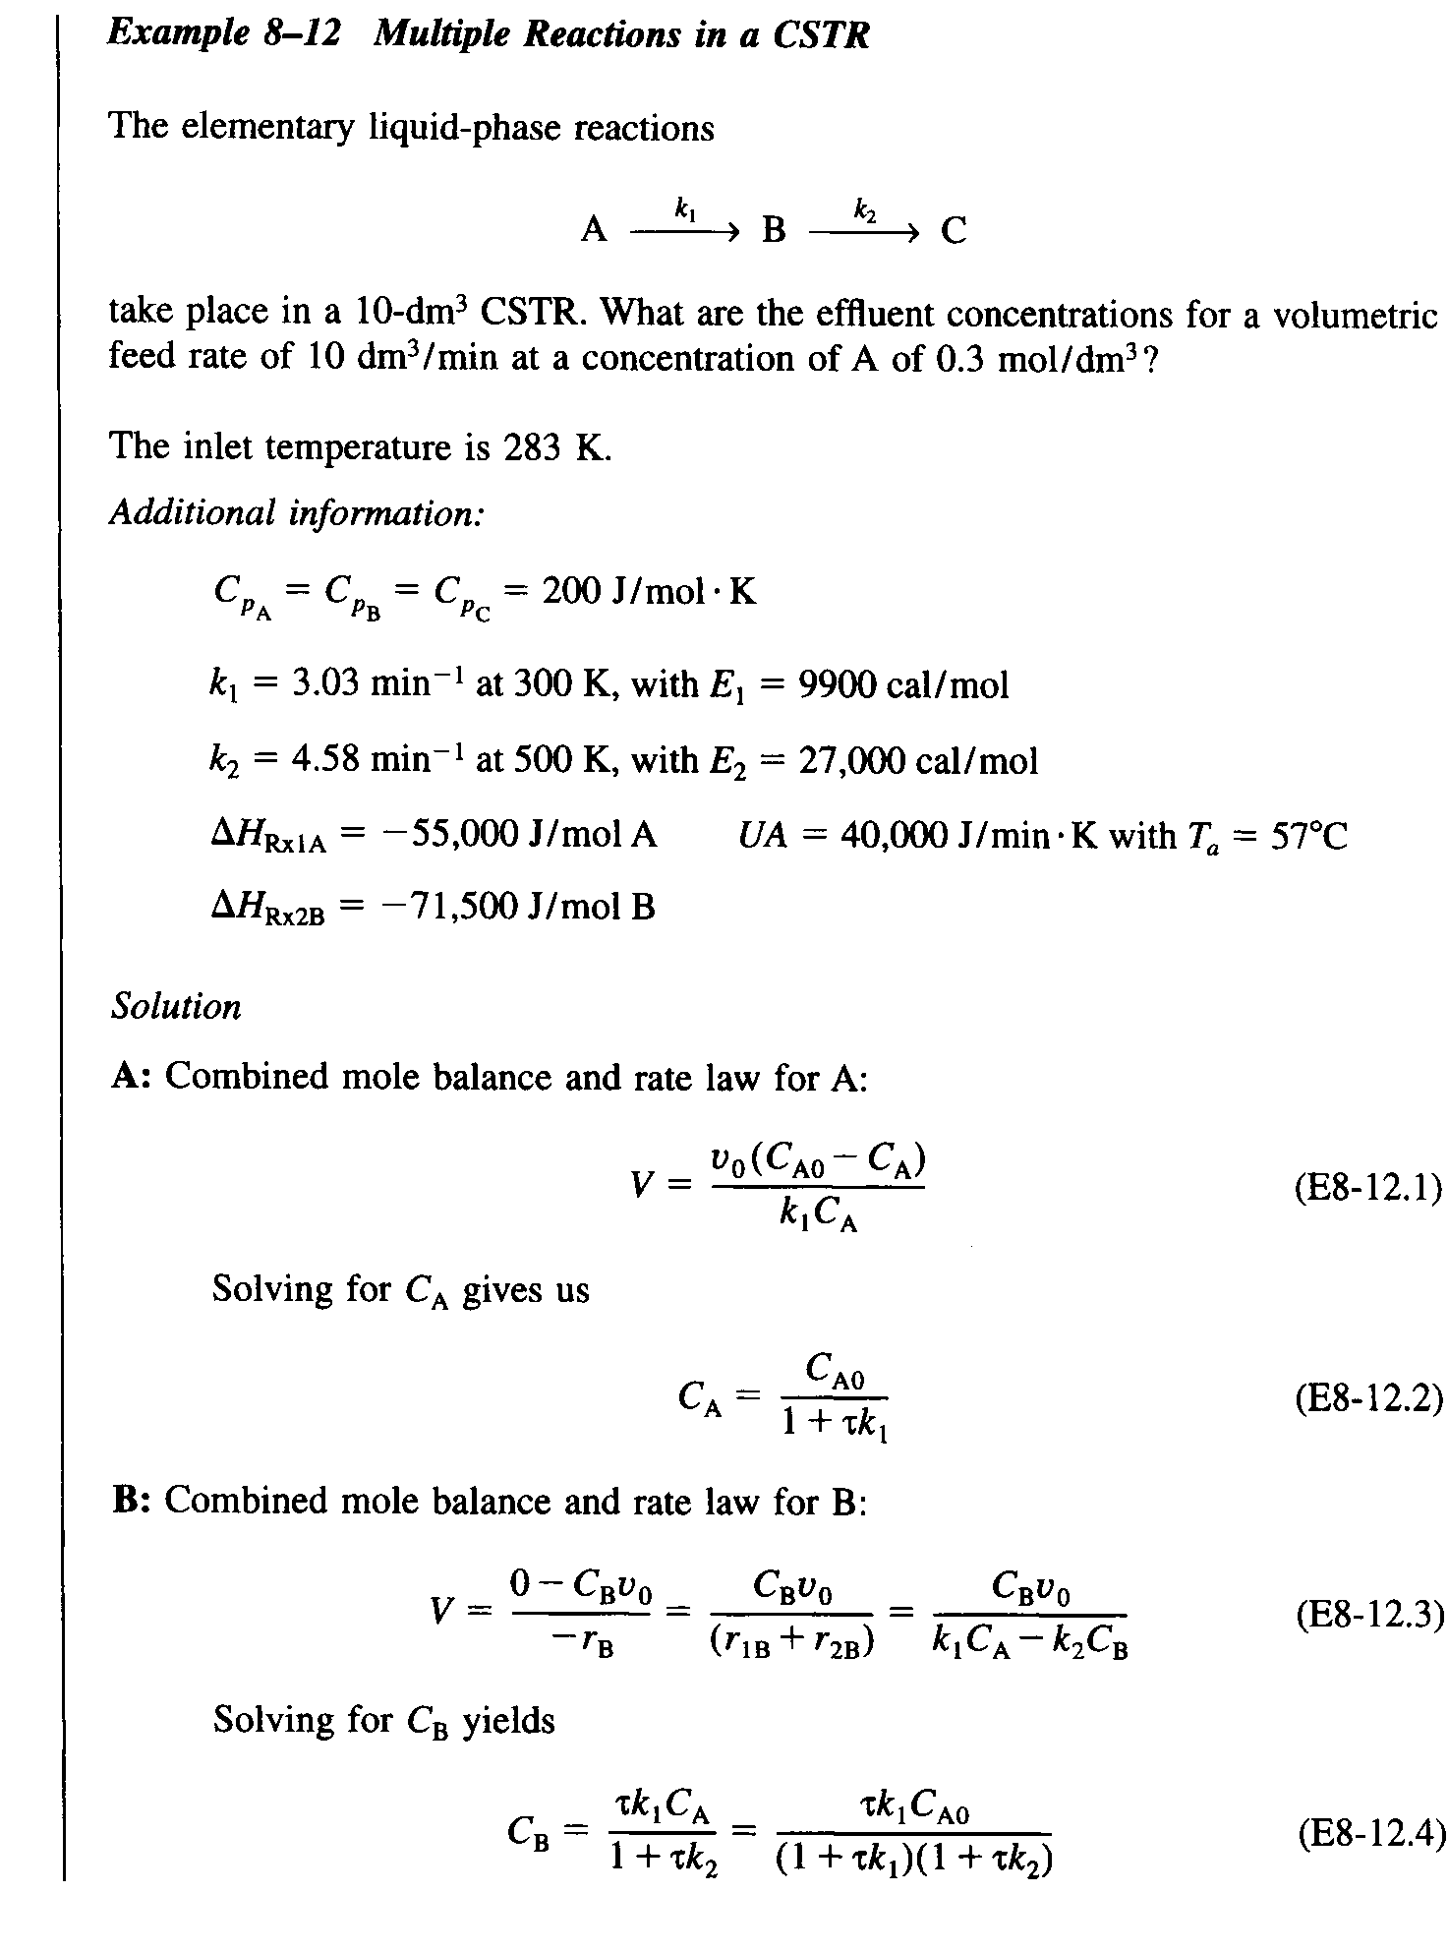
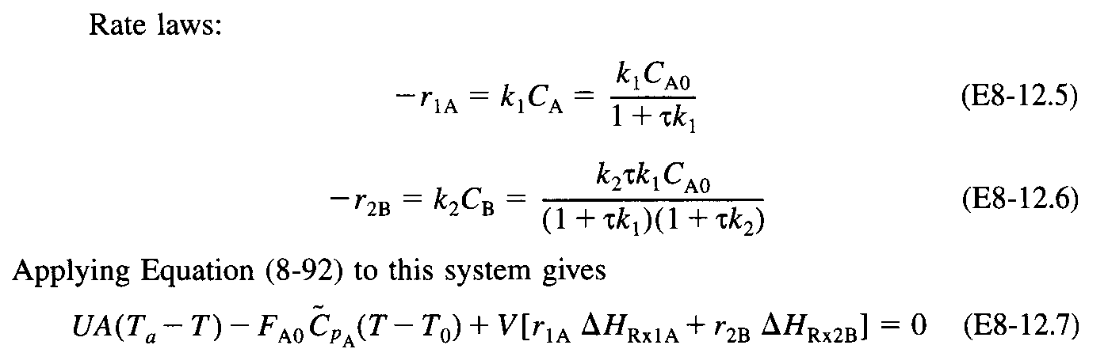
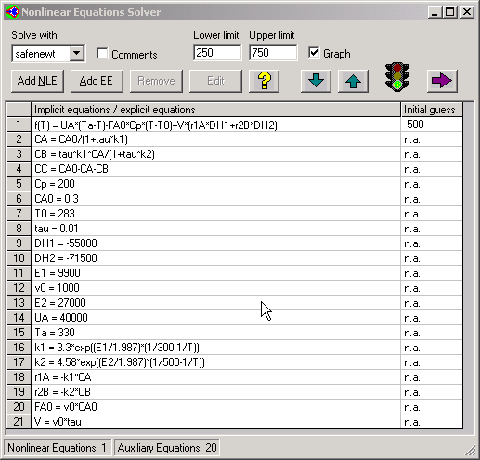

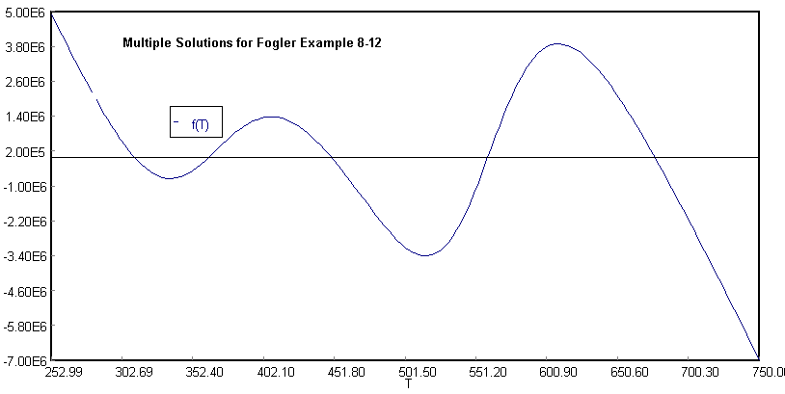
POLYMATH Results
Fogler Example 8-12 04-18-2003, Rev5.1.230

NLE Solution

Solution #1 of 5
Variable Value f(x) Ini Guess
T 311.08782 -1.281E-09 500
E1 9900
E2 2.7E+04
k1 5.9647338
Cp 200
CA0 0.3
T0 283
tau 0.01
DH1 -5.5E+04
DH2 -7.15E+04
CA 0.2831131
v0 1000
k2 3.116E-07
UA 4.0E+04
Ta 330
CB 0.0168869
CC 5.261E-11
r1A -1.688694
r2B -5.261E-09
FA0 300
V 10

Solution #2 of 5
Variable Value f(x) Ini Guess
T 363.04679 -9.313E-10 500
E1 9900
E2 2.7E+04
k1 59.031023
Cp 200
CA0 0.3
T0 283
tau 0.01
DH1 -5.5E+04
DH2 -7.15E+04
CA 0.1886424
v0 1000
k2 1.616E-04
UA 4.0E+04
Ta 330
CB 0.1113574
CC 1.8E-07
r1A -11.135756
r2B -1.8E-05
FA0 300
V 10

Solution #3 of 5
Variable Value f(x) Ini Guess
T 449.34469 -5.588E-09 500
E1 9900
E2 2.7E+04
k1 823.66131
Cp 200
CA0 0.3
T0 283
tau 0.01
DH1 -5.5E+04
DH2 -7.15E+04
CA 0.0324794
v0 1000
k2 0.2139601
UA 4.0E+04
Ta 330
CB 0.2669494
CC 5.712E-04
r1A -26.752056
r2B -0.0571165
FA0 300
V 10

Solution #4 of 5
Variable Value f(x) Ini Guess
T 558.99072 -3.725E-09 500
E1 9900
E2 2.7E+04
k1 7249.5387
Cp 200
CA0 0.3
T0 283
tau 0.01
DH1 -5.5E+04
DH2 -7.15E+04
CA 0.0040819
v0 1000
k2 80.613945
UA 4.0E+04
Ta 330
CB 0.1638401
CC 0.132078
r1A -29.591811
r2B -13.207799
FA0 300
V 10

Solution #5 of 5
Variable Value f(x) Ini Guess
T 676.35128 -7.451E-09 500
E1 9900
E2 2.7E+04
k1 3.404E+04
Cp 200
CA0 0.3
T0 283
tau 0.01
DH1 -5.5E+04
DH2 -7.15E+04
CA 8.787E-04
v0 1000
k2 5473.7334
UA 4.0E+04
Ta 330
CB 0.0053666
CC 0.2937547
r1A -29.912128
r2B -29.375466
FA0 300
V 10

NLE Report (safenewt)

Nonlinear equations
[1] f(T) = UA*(Ta-T)-FA0*Cp*(T-T0)+V*(r1A*DH1+r2B*DH2) = 0

Explicit equations
[1] E1 = 9900
[2] E2 = 27000
[3] k1 = 3.3*exp((E1/1.987)*(1/300-1/T))
[4] Cp = 200
[5] CA0 = 0.3
[6] T0 = 283
[7] tau = 0.01
[8] DH1 = -55000
[9] DH2 = -71500
[10] CA = CA0/(1+tau*k1)
[11] v0 = 1000
[12] k2 = 4.58*exp((E2/1.987)*(1/500-1/T))
[13] UA = 40000
[14] Ta = 330
[15] CB = tau*k1*CA/(1+tau*k2)
[16] CC = CA0-CA-CB
[17] r1A = -k1*CA
[18] r2B = -k2*CB
[19] FA0 = v0*CA0
[20] V = v0*tau

Settings
Max iterations = 150
Tolerance F = 0.0000001
Tolerance X = 0.0000001
Tolerance min = 0.0000001

Fogler Text Multiple Steady State Solutions
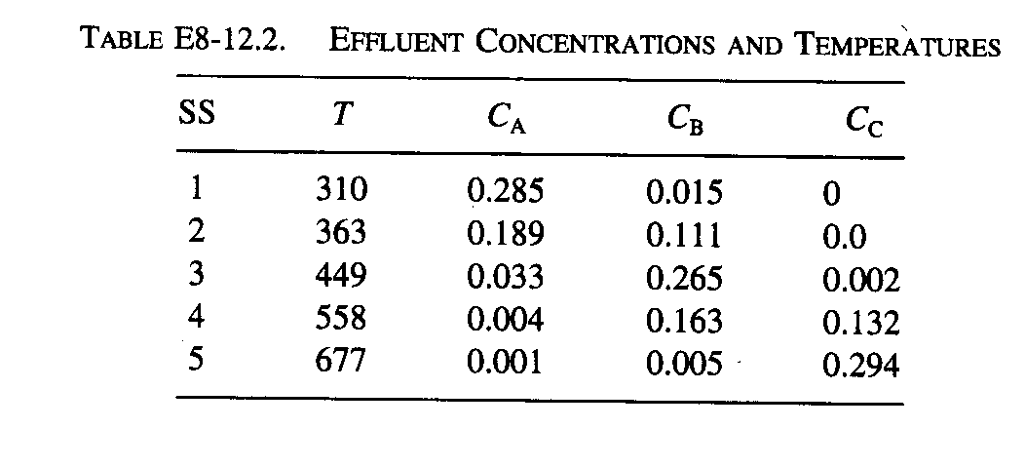
Direct Solution of Nonlinear Equations
Solution #1 of 5
Variable Value f(x) Ini Guess
T 311.08782 -1.281E-09 500
Solution #2 of 5
Variable Value f(x) Ini Guess
T 363.04679 -9.313E-10 500
Solution #3 of 5
Variable Value f(x) Ini Guess
T 449.34469 -5.588E-09 500
Solution #4 of 5
Variable Value f(x) Ini Guess
T 558.99072 -3.725E-09 500
Solution #5 of 5
Variable Value f(x) Ini Guess
T 676.35128 -7.451E-09 500

