**American Sign Language Club Fundraiser**

A great cause

and some great food

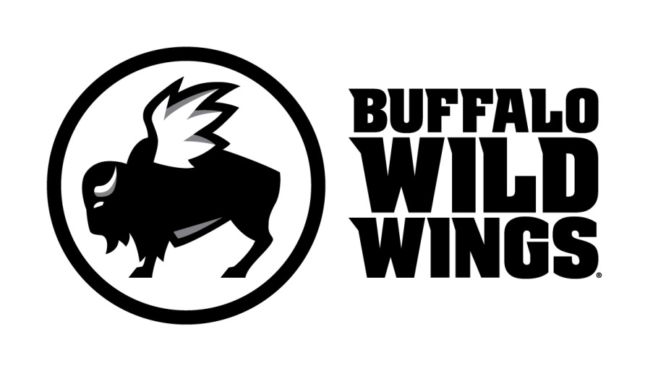

All friends, family and supporters of American Sign Language Club

are invited to participate in their fundraising event on

**Wednesday, December 11th, 2013**

Everyone is invited to gather at Buffalo Wild Wings in Ann Arbor (205 South Street) for lunch, dinner, or a snack. On this day, 20% of purchases* accompanied by the certificate below will be donated to

**American Sign Language Club.**

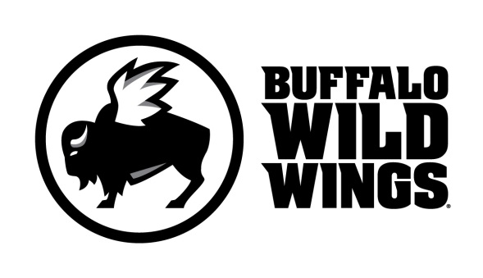

**American Sign Language Club Fundraiser**

**Wednesday, December 11th, 2013**

Present this certificate to your server at the

time of your order and 20% of your

purchases* will go to support

**American Sign Language Club.**

**Only valid at 205 South State Street, Ann Arbor, MI (734) 997-9143**